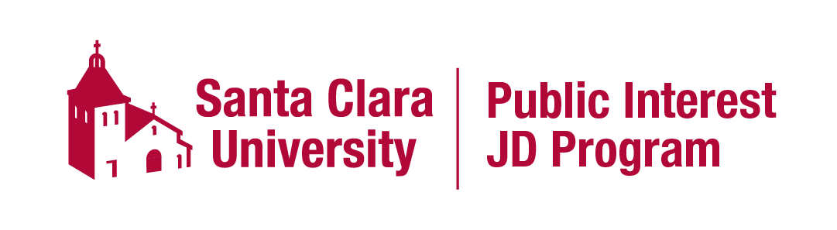
Requirements for Public Interest JD graduates
A PIJD certificate candidate must satisfy the following requirements:
1. Graduation Application. A candidate must create and maintain documentation evidencing completion of the certificate requirements listed below. A PIJD graduation application will be available by Jan 1 and must be submitted by March 15 of 3L year.
2. Academic Plan. Candidates must meet at least once each year with their faculty advisors to discuss progress towards completion of the PIJD requirements and plans for completing those requirements. Academic plans will be submitted by May 15 of the student’s 1L year and 2L year. Academic plans should document the coursework, experiential learning, and milestones already completed, as well as the student’s plans for completing additional coursework, experiential learning and milestones during the next academic year. Academic plans should be submitted first to the faculty advisor for his/her signature, and then to the program directors for their signatures.
3. Career Plan. A candidate must meet at least once each year with a career advisor from the Office of Career Management (OCM) to discuss career options in the government and/or non-profit sectors. Students will write a career plan in conjunction with OCM and discuss the plan with one of the program directors during the 1L year. The plan shall be updated yearly. Initial plans will be submitted by May 15 of the student’s 1L year and 2L year. The final plan will be submitted to the program directors by March 15 of the 3L year. Each iteration of the career plan should include: (a) a statement of career goals; (b) a summary of networking activities during the past year and plans for networking activities during the coming year; (c) a summary of any work experience over the past year, or planned for the following year, for which the student did not receive academic credit, as well how that work has or will contribute to the student’s career goals; (d) an explanation of how experiential learning activities completed during the past year, or planned for the next year, have contributed or will contribute toward the student’s career goals; (e) an explanation of how milestones completed during the past year, or planned for the next year, have contributed or will contribute toward the student’s career goals. All career plans should be submitted first to the OCM career advisor for his/her signature, and then to the program directors for their signatures.
4. Public Interest Coursework. A candidate must complete 16 units of public interest related elective coursework. This requirement includes units earned in the experiential learning requirement (see #5, below). Currently, courses that will count can be found on the PIJD wesbite. The list of academic courses that will satisfy this requirement will be updated periodically by the program directors. Students may petition for a course to be added.
5. Experiential Learning. A candidate must complete at least three semesters of experiential learning, including at least one semester of clinic work of at least 3 units, and at least one externship of at least 3 units related to the student’s focus. Currently, courses that will count for experiential learning can be found on the PIJD website. The list of courses that will count toward a semester of experiential learning will be updated by the Program Directors periodically. Students may petition for a course to be added.
6. Milestone Experiences. Complete at least six (6) of the milestone activities listed below. Within two weeks of completion of the milestone, fill out the Milestone Verification form for program director approval found on the PIJD website. Your form should include the verification information required for the specific milestone, which can be found on the Detailed Milestone Instructions for Public Interest JD Students found on the PIJD website. Program directors will either sign-off on the milestone or offer additional feedback to the student within two weeks of submission.
  - Interview an individual client, under the supervision of an attorney. Prepare a summary and legal analysis of the client’s claim or claims, based on that interview;
  - Attend a judicial proceeding that is directly related to a client’s case;
  - Draft a document that can be used to expose a significant problem, or that can be used in either a legislative or policy advocacy campaign or in litigation on behalf of an actual client;
  - Participate in an advocacy campaign that is designed to persuade relevant officials to enact a legislative or policy reform;
  - Engage in problem-solving, evaluation of alternative options, and strategizing in collaboration with a supervisor and colleagues on possible means of accomplishing a client’s goals or addressing a major public policy issue;
  - Evaluate, discuss, and propose resolution of an actual or simulated ethical issue related to legal practice;
  - Evaluate, discuss, and propose resolution of an actual or simulated public policy issue related to government or public interest lawyering;
  - Experience or participate in discussion of extra-judicial means of resolving legal issues, including through alternate dispute resolution or through legislative, administrative, or executive means;
  - Participate in a cross-disciplinary team that includes, in addition to lawyers, social workers, medical personnel, law enforcement, experts in other fields, and/or practitioners’ or scholars in other disciplines.
  - Attend a meeting of a legislative or policy-making body, such as a City Council meeting; and
  - Meet individually with at least three practicing attorneys who work in different kinds of jobs in the government and/or nonprofit sectors to learn from them about their work and their career paths.

