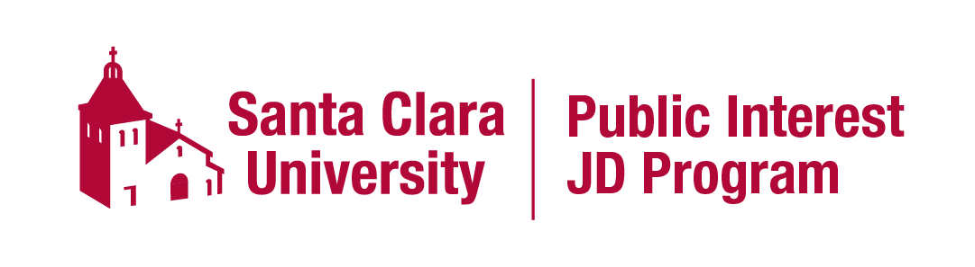
PIJD Program Elements
1. Orientation. All PIJD candidates will attend an orientation session before the beginning of 1L year, where careers in public interest law will be explored. PIJD students must also attend the “regular” law school orientation. The in-person orientation session will be during the week of the regular orientation to minimize the travel burden on out-of-state students.
2. Mentors. All candidates will be assigned up to two (2) attorney mentors. Candidates will generally meet with each mentor one or two times per year. At least once during the three years of law school, candidates should arrange a shadow day or other field trip experience with a mentor.
3. Law School Advisor. A candidate will be assigned one (1) law school advisor, which may be either a faculty or staff member. The candidate must meet with the advisor at least once per year. The advisor will review the student’s progress towards graduation and the PIJD graduation requirements.
4. Career and Academic Planning. Students will create and maintain both a career plan and an academic plan. See the document on PIJD graduation requirements for details.
5. Experiential and Academic Learning. All candidates will complete at least 16 units of public interest coursework, including three semesters of experiential learning. Students will complete at least six (6) milestones demonstrating public interest experience.
6. Other Details
Applicants to the part-time program are not currently eligible for the PIJD program. A full-time student may only be admitted to the PIJD program prior to the 1L year (but not thereafter).
All certificate requirements must be completed prior to the candidate’s graduation date. Students cannot earn both the PIJD certificate and another certificate. Students are eligible for other graduation honors and awards (such as Pro Bono Awards, Dean’s Leadership Awards, etc.)
The program directors may terminate a student’s participation in the PIJD program if they believe that the program may jeopardize the student’s completion of graduation requirements and/or bar passage.
The PIJD Directors have authority to waive certificate requirements. Waivers will be granted only in exceptional cases. PIJD candidates may opt out of the program at any time. A student who has opted out will not be eligible for re-entry into the program.
Some PIJD students may be eligible for Public Interest scholarships. These scholarships will be awarded at the time the student is presented with an offer for admission into the program. Students who opt out of the PIJD program will no longer be eligible for Public Interest scholarships. All active PIJD students may use the designation “Public Interest Scholar.” Students who are terminated from the program or withdraw from the program may not continue to use the Public Interest Scholar designation.

