Law Reunion, Topical Alumni Panel: “The Impact of Diversity Within Legal Services”

When: Friday, October 13, 4:30 p.m. – 5:15 p.m. PST
Where: Charney Hall, Room 102
MCLE Credit: 0.75 hours (Elimination of Bias)

Summary
The legal field has become increasingly diverse in recent decades with newly licensed attorneys better reflecting California’s rich and varied demographics. However, much work remains. The State Bar of California recently prepared its Report Card highlighting the Diversity of California’s Legal Profession, accessible here.

Join us as Delma Locke (JD ’95), Chief Legal Officer at Reali; Orlena Fong Shek (JD ’03), Author of Emerging from the Smoke: A Collection of Warrior Voices; Ralph Robles Jr. (JD ’12), Founder of the Law Offices of Ralph Robles Jr; and Huy Tran (JD ’12), Co-Founder and Partner at Justice at Work Law Group LLP, share how diversity in the profession positively impacts legal services and ideas for how we can get involved in increasing diversity within the profession.

Panelists
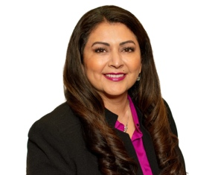
Delma Locke, Class of 1995
Chief Legal Officer, Reali

Orlena Fong Shek, Class of 2003
Author, Emerging from the Smoke: A Collection of Warrior Voice

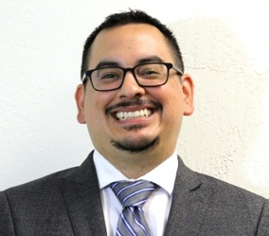

Ralph Robles Jr., Class of 2012
Founder of the Law Offices of Ralph Robles Jr

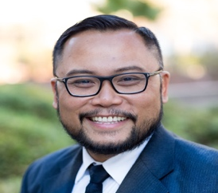
Huy Tran, Class of 2012
Co-Founder and Partner at Justice at Work Law Group LLP

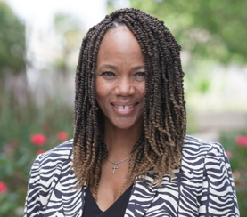
Event Moderator

Deborah Moss-West, Class of 1994
Executive Director, Katharine & George Alexander Community Law Center

