Santa Clara Law Summer Study Abroad

Singapore – Housing

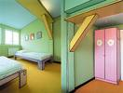

Orienting Yourself
There are a number of housing options available in Singapore, from hotels and hostels, to serviced or unserviced apartments. Finding the right housing for a long stay in a foreign city is not easy. For reference purposes, the Orchard Road area (Orchard, Somerset, Dhoby Ghaut MRT stations) tends to be the busy center of town “Being at the epicentre of Singapore's shopping and entertainment industries means Orchard Road never sleeps. Other than being a shopper’s heaven, it is also a great haunt for fabulous fine-dining and swanky restaurants.”
Our university is located near the MTR/Bras Basah station, and the Singapore Management University law school is at the intersection of Stamford and Fort Canning roads .
You can find a useful Singapore map, including a sub link to MRT and local transportation, at http://www.onemap.sg/index.html The university map is at http://www.smu.edu.sg/campus/map/index.asp
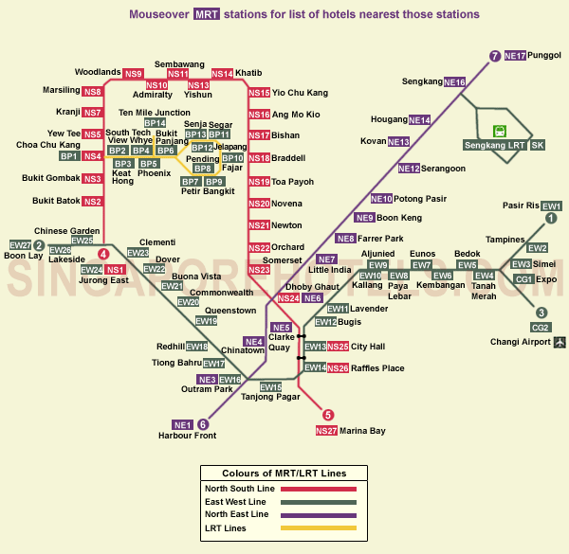

A note about rates: Rates may be quoted in Singapore $$, so make sure you do the appropriate conversion before making a final decision.
Former Student Suggestions
Perhaps your most important resource, here are some suggestions offered by former program participants:
Students suggest the following locations, but they also suggest looking on CraigsList. Here’s where they stayed:
1. Pillows & Toast. A relatively new hostel, this soon became a student favorite. http://www.pillowsntoast.com/
2. Footprints Hostel. Student comment: “ … located in Little India and we took one bus that was a straight shot to campus. Took about 15 mins to get to campus. I really loved their staff. The place can get a little rowdy but it was still comfortable. Their number is +65 6295 5134.” http://www.footprintshostel.com.sg/
3. Superb Hub hostel @ Bugis. Student comment: “Stayed for about ten days and then sublet and apartment from craigslist [information below]. The hostel was about $40 US per night I think.” http://www.superbhub.co.cc/
4. Three students shared an apartment, paying between $20-35 per night. They found it off CraigsList. The apartment is located at Apt 08-11, 9 Lorong 27A, Geylang 388134. The nearest bus stop is a 2minute walk, and the nearest train station a 5 minute walk. That train station is Aljunied, which is on the green line and four stops from City Hall which is the central hub. Geylang is a very central location for buses as well. The contact person was Matt Bowyer (mattbowyer@gmail.com), and his phone number was 84373201. This person may have left Singapore, but could get you in touch with the landlord perhaps.
5. Hanson Court Studio Apartments. Student comment: “A good deal, furnished, clean.” The apartments are located on Kim Keat Road, near Balestier Road. They can be reached via email at francis@lamipak.com, or telephonically at 81616661, 93371116, or 93371116. If calling Singapore from the US, dial 011-65, and then the telephone number.
6. Novena Hall. http://www.novenahall.com.sg/. “I think I paid a little bit more than most people--I want to say my rent was between $550 and 700 per month (don't quote me). However, I absolutely loved living there because it was quiet, safe and it was not a hostel. I would describe it more as a college dorm because only students and young working professional can stay there--and I met a lot of friends there--I had a fantastic roommate from Delhi. Had I been in Singapore for just the class session, I know that a hostel would have been more than fine for me but knowing that I was staying in Singapore for about 11 weeks I wanted something that was more comfortable and that also had a private bathroom. … I believe that my commute was 20-30 minutes each way and that includes the walking time as well. I think the only drawback to the Novena area is that if you want to party/go out at night you really do need to get out of the Novena area.”
Hotels
You may find some good hotel rates through STA Travel or Agoda.
http://www.statravel.com/ http://www.agoda.com/ 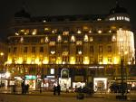
Hotel prices range upwards from around US $30 per day. Prices may be quoted in Singapore $$. Beware that reservations may require a non-refundable pre-payment for the entire duration of reservation. Make sure you check the customer reviews before committing to long-term arrangements!
Hostels
Options abound, but make sure this is what you want before you sign up for this. Here are some suggestions: (besides places suggested by students above)

Sleepy Sams www.sleepysams.com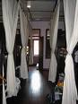
Inncrowd Hostel http://www.the-inncrowd.com/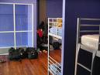
Private Hostels http://www.nus.edu.sg/osa/housing/forms/pte_hostels_list%20as%20of%2011%20Feb%2009.pdf
Other hotels listing http://www.visitsingapore.com/publish/stbportal/en/home/apps/hotel_search.html

Serviced Apartments
Serviced apartments are great since they usually come fully furnished, offer you cooking facilities, and can be shared with one or more students.
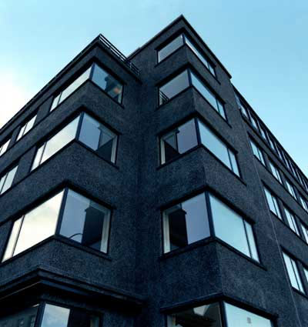
- While many rental services are available, students have used Wilby Central Serviced Apartments in the past www.wilby.com.sg You can email them at wilbycl@tcil.com.sg
- You may find some of the best rates through Agoda http://www.agoda.com/

